1. What was your level of comfort with the lesson/application?

I was very comfortable with both the lessons and the applications. However, I do have a couple questions regarding syntax and other things you used in the lessons:

* I have never used semicolons in R before - Do they have the same use as in SAS where it is the end of a line of command? Pretty much. If so, why would one do this besides just pressing enter and starting a new line of code?
  + Actually, ENTER does not always happen at an end-of-command -- your GGPlot code has many ENTER that do not mean end-of-command. So, semi-colons are a more explicit way of saying end-of-command. Semicolons are required in many languages (like C, Java). You can also use then to put more than one command on a line. They are really helpful if you are using a debugger -- I am not sure we will get to the debugger in this class.
* What are the distinctions between using “=” and “<-“ for creating datasets and lists? I usually use “<-“ when importing datasets, etc.
  + I have not seen any. Classically, there was a difference but that was back in R 1.0.
* I usually work with big datasets, so I use read_csv from tidyverse. Do you have any issues with that command? It seems quicker and has a nice progress bar.
  + No issues with that

1. What areas of the lesson/application confused or still confuses you?

I kept getting unexpected end of document warnings. Why?

1. What is a way you can apply the material in this lesson towards your research or area of study?

For a given year, I can plot the amount of payments doctors received from certain pharmaceutical companies against the number of deaths from side effects of the drugs said companies advertised on the county level.

1. What are some things you would like to learn related to, but not covered in, this lesson?

Related to importing .csv files: Are there different ways for R to store the data you upload to it? It seems like R uses a lot of RAM to store data in my experience. Are there ways to save datasets on a drive and call them up without storing them in RAM?

I had to read up on this. It seems that the way to do this is to put your data into a database (e.g., SQL) and then query the database. That is a very surface level answer and something which I will look back into but probably not until after class.

How to visualize a multivariable regression with scatterplot. (See below)

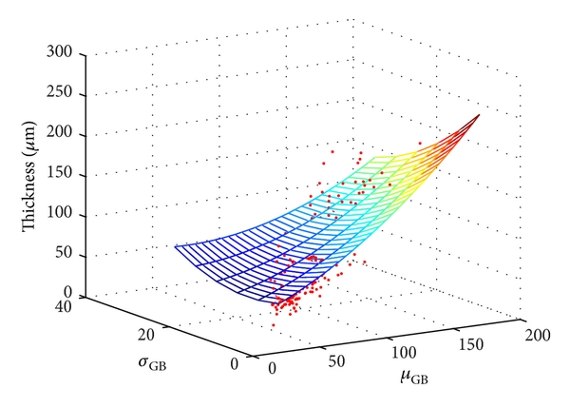

GGPlot does not natively support 3D plots. Philosophically, GGPlot was opposed to 3D plots. I am not going to take a position on this… There are GGPlot packages that do (plotly, gg3d) but I have played with them yet.

Grammar of graphics